

**HTU_COFFEE**

**By walaa hdaib**



HTU upskilling programme

PHP FULL-stack

Preabeared by:

Walaa Hdaib

**TABLE OF CONTENTS**

1. **INTRODUCTION**
   1. **preamble**
   2. **Project Motivation**
   3. **Problem statement**
   4. **Project Aim and Objective**
   5. **Project Scope**
   6. **Project Software and Hardware Requirements**
   7. **Project Limitations**
   8. **Project Contributions (Expected Output)**
2. **PROJECT BACKGROUND AND EXCITING SYSTEM**
   1. **Introduction**
   2. **Existing Systems**
   3. **Overall Problems of Existing Systems**
   4. **Overall Solution Approach**
3. **SYSTEM REQUIREMENTS AND ANALYSIS**
   1. **Introduction**
   2. **Feasibility Study**
   3. **Operational Feasibility**
4. **SYSTEM DESIGN**
   1. Introduction
   2. **Entity Relationship Diagram**
   3. **Use-case diagram**
   4. **Database Design**
5. **SYSTEM IMPLEMENTATION**
   1. **Introduction**
   2. **Database Implementation**
   3. **Graphical User Interface Implementation**
6. **CONCLUSION AND FUTURE WORK**

**6.1 Introduction**

**6.2 Overall Weakness**

**6.3 Overall strengths**

**6.4 Future work**

1. **REFERENCES**

**TABLE OF figures**

**1-** *Figure 1: Entity relationship model*

**2-** *Figure 2: admin use case diagram*

**3-** *Figure 3: seller use case diagram*

4- *Figure 4: accountant use case diagram*

5- *Figure 5: procurement use case diagram*

6- *Figure 6: database design model*

7- *Figure 7: items DB table*

8- *Figure 8: users DB table*

9- *Figure 9: transaction DB table*

10- *Figure 10: usr-transaction DB table*

11- *Figure 11: login page*

12- *Figure 12: admin dashboard page*

13- *Figure 13: all items page*

14- *Figure 14: single item page*

15- *edit item page*

16- *creat item page*

*17- Figure 17: all users page*

*18- single users page*

*19- Figure 19: edit users page*

20- Figure 20: create users page

21- Figure 21: sales page

22- Figure 22: all transaction page

23- Figure 23: single transaction page

24- Figure 24: 404 page

25- Figure 24: edit transaction page

1. **INTRODUCTION**

**1.1 preamble**

Point of sale (POS) systems is used by businesses to process transactions with customers. POS systems typically include a computer, a cash register, and a payment terminal, and they are used to track sales, process payments, and manage inventory. In order to facilitate and streamline sales transactions and inventory management at the store located within King Abdullah Business Park, HTU has decided to implement a Point of Sale (POS) web application. With a diverse team of employees utilizing the system, the POS administrator requires immediate access to detailed information about total sales, specific transactions, and current stock levels for each item.

**1.2 Project Motivation**

The motivation behind our project is to create a Point of Sale (POS) website that effectively addresses the challenges faced by HTU in managing the store at King Abdullah Business Park. The POS system will be responsible for processing transactions with customers, tracking sales and inventory, and providing the administrator with real-time data about the store's performance. Additionally, the POS website will be designed to be user-friendly and intuitive, ensuring that it can be easily utilized by employees with a variety of roles. Overall, our goal is to develop a reliable and efficient POS system that enables HTU to effectively manage their store and drive business success.

**1.3 Problem statement**

Because of current manual processes used to manage customer transactions, track sales and inventory, and provide real-time data to the administrator are time-consuming and prone to errors, leading to inefficiencies and a suboptimal customer experience. Therefore, there is a need for a POS website that can streamline these processes and provide the necessary data and functionality to effectively manage the store.

**1.4 Project Aim and Objective**

**Project goals:**

●To automate the process of handling customer transactions and tracking sales data, improving efficiency and accuracy.

●To provide the administrator with real-time data about the store's performance, including sales, inventory levels, and customer information.

●To continuously maintain and update the POS system to ensure it remains reliable and effective in meeting the needs of the store.

●To ensure the POS system is user-friendly and intuitive, enabling easy use by employees with a variety of roles.

**Project Objectives:**

The aim of the POS system project is to develop a web application that can effectively handle customer transactions, track sales and inventory, and provide real-time data to the administrator at HTU's store at King Abdullah Business Park.

**1.5 Project Scope**

Our website is designed to include the development of a web application that can process transactions, track sales and inventory, and provide real-time data to the administrator.

**1.6** **Project Software and Hardware Requirements**

**1.6.1 Software Requirements**

**Table 1: Software requirements for POS_CAFFEE website**

|  |  |
| --- | --- |
| **Software** | **Requirement** |
| **Operating System** | **MacOS,Windows 8.1 or higher operating systems** |
| **Browser** | **Firefox 3.0, Safari 4.1.2, and Google Chrome 11.0, all of these browsers in the minimum versions.** |
| **Local server** | **XAMPP,MAMP** |
| **Development tools** | **Visual Studio Code** |
| **Database server** | **MySQL** |

**1.6.2** **Hardware Requirements**

**Table 2: Hardware requirements for POS_CAFFEE website**

|  |  |
| --- | --- |
| **Hardware** | **Requirement** |
| **Memory(RAM)** | **2 GB or 4 GB or higher** |
| **Hard Disk** | **500 GB or more** |
| **CPU** | **1.9 gigahertz (GHz) x86- or x64-bit dual core processor with SSE2 instruction set** |
| **Server** | **Internet connection** |

**1.7 Project Limitations**

● Need an internet connection to access the website.

● The website language is in English.

**1.8** **Project Contributions (Expected Output)**

a Point of Sale (POS) web application to handle store sales transactions and stock. There are many employees with different roles that will work on the POS. The admin of the POS system wants to see quick information on the total sales and transactions in addition to the stock of each item.

2. **PROJECT BACKGROUND ANDEXISTING SYSTEM**

## **2.1** **Introduction**

This chapter talks about the existing systems and what is the problem inside these systems. As well as the overall solution approach to those problems.

**2.2 Existing Systems**

There are numerous point of sale systems available for cafes, but what sets our system apart is its ease of use and ability to meet the needs of any cafe.

In addition, our system includes a menu management system that allows cafe owners to easily update and manage their menu items and prices.

Here are some examples of point of sale systems for cafes:

● Square is a popular point of sale system that allows cafes to accept card and mobile payments, track sales and inventory, and manage employee schedules.

● ShopKeep is a cloud-based point of sale system that offers a range of features for cafes, including inventory management, customer tracking, and sales reporting.

● Lightspeed is a point of sale system that offers advanced reporting and analytics tools for cafes, as well as the ability to manage multiple locations and integrations with popular accounting software.

**2.3 Overall Problems of Existing Systems**

One of the main problems with existing point-of-sale systems for cafes is that they can be difficult to set up and configure, and may not offer all of the features that a cafe owner is looking for. These systems can also be expensive, and may not easily integrate with other tools that a cafe owner is using. Additionally, some point-of-sale systems may not offer good customer support, making it difficult for cafe owners to get help when they need it.

**2.4 Overall Solution Approach**

To address the problems with existing point-of-sale systems for cafes, a good system should be easy to use and offer a comprehensive feature set to meet the needs of the cafe. It should also be able to integrate with other tools and offer good customer support. Additionally, it should be compatible with various hardware that a cafe might use.

3. **SYSTEM REQUAIMENT AND ANALYSIS**

**3.1 Introduction**

**This chapter includes in detail about the system requirements and system analysis with full description about the functionality of the system including the definition and the specification for each requirement.**

**3.2 Feasibility Study**

**3.2.1 Technical Feasibility**

**Our system is a web based application and the main technologies and tools that are associated with this project are**

**For Front-end we will use :**

**● HTML**

**● Css**

**● Bootstrap**

**● Javascript**

**For Back-end we will use :**

**● PHP**

**● MYSQL**

**the system will be available all the time and at any place while there is internet connection.**

**3.3Operational Feasibility**

**web based applications are familiar to a wide range of users. The front-end content and design layout are straightforward and friendly to use. This project will benefit users with the services they need providing adequate throughput and response time, which makes them satisfied with the results.**

1. **SYSTEM DESIGHN**

**4.1 Introduction**

System design is the process that describes the system architecture, components, database design, output layouts, user interfaces, detailed design, and processing logic for a system. This chapter includes many important figures that describe our system process, it will include

entity relation diagram (ERD), use cases diagrams, database designs.

**4.2 Entity Relationship Diagram**

Entity Relationship Diagram, also known as ERD, ER Diagram or ER model, is a type of structural diagram for use in database design. An ERD contains different symbols and connectors that visualise two important pieces of information: The major entities (User, Product, Sub-Categories, Categories, Order) within the system scope, and the inter-relationships (buy, has) among these entities.

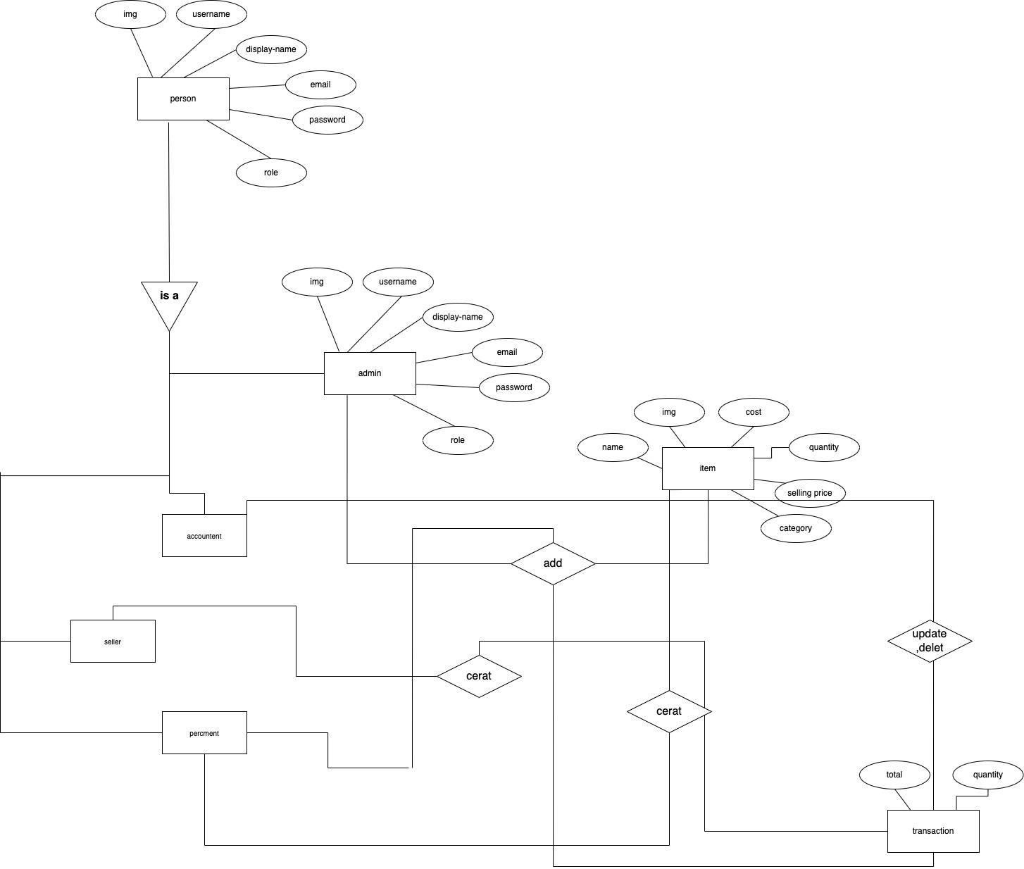

*Figure 1: Entity relationship model*

**4.3 Use-case diagram**

A UML use case diagram is the primary form of system/software requirements for a new software program underdeveloped. Use cases specify the expected behaviour (what), and not the exact method of making it happen (how). Use cases once specified can be denoted both textual and visual representation (i.e. use case diagram). A key concept of use case modelling is that it helps us design a system from the end user's perspective. It is an effective technique for communicating system behaviour in the user's terms by specifying all externally visible system behaviour.

**4.3.1 Admin use case diagram**

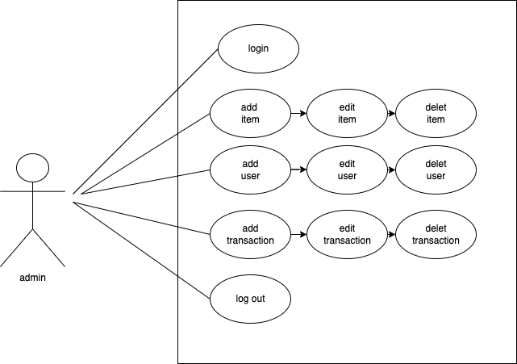

*Figure 2: admin use case diagram*

**4.3.2 seller use case diagram**

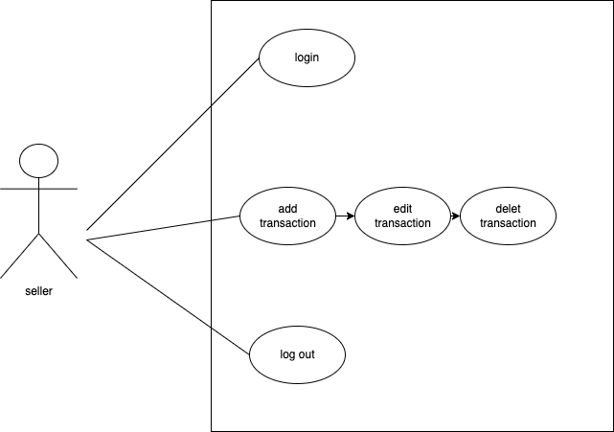

*Figure 3: seller use case diagram*

**4.3.2 accountant use case diagram**

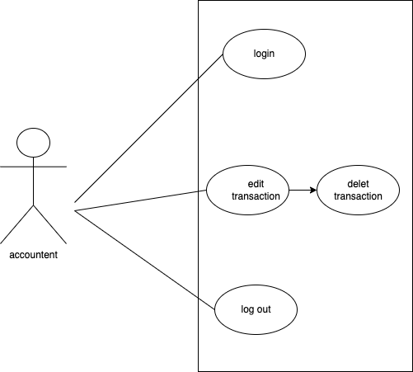

*Figure 4: accountant use case diagram*

**4.3.2 procurement use case diagram**

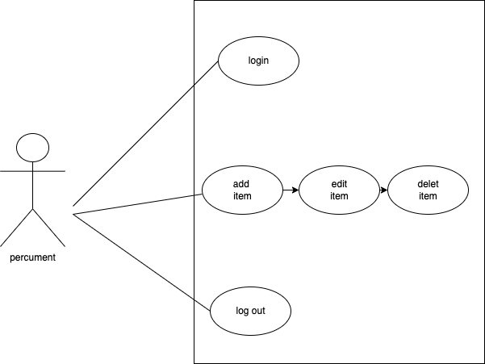

*Figure 5: procurement use case diagram*

**4.4 Database Design**

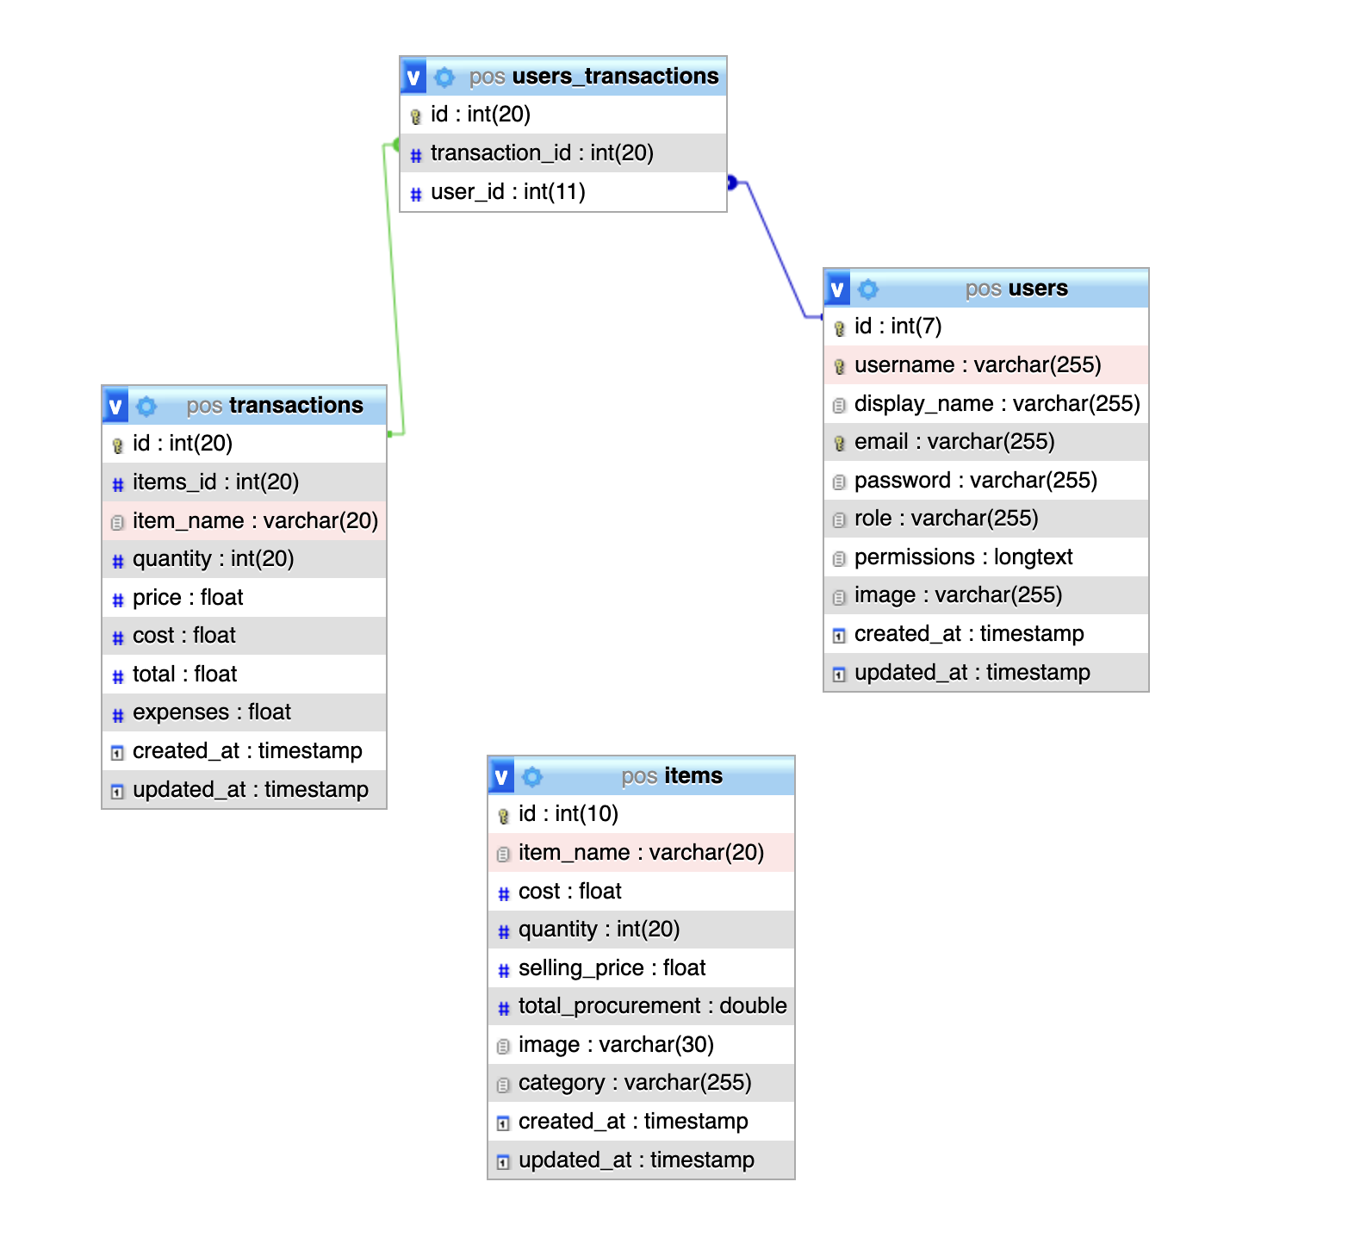

*Figure 6: database design model*

1. **SYSTEM IMPLEMENTATION**

**5.1 Introduction**

In this chapter, the website implementation is discussed. In section 5.2 we will show the Database implementation, the graphical user interface (GUI) is presented in section 5.3.

**5.2 Database Implementation**

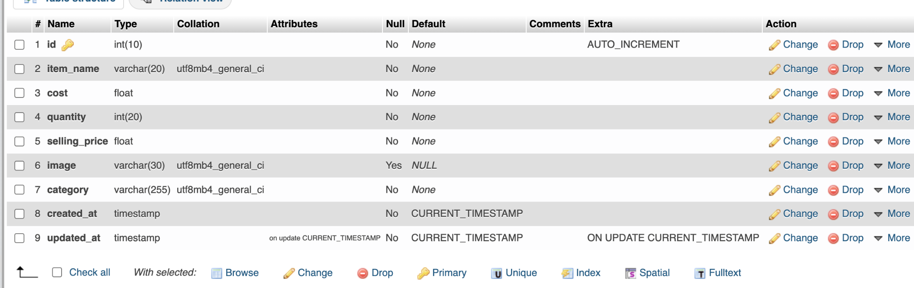

*Figure 7: items DB table*

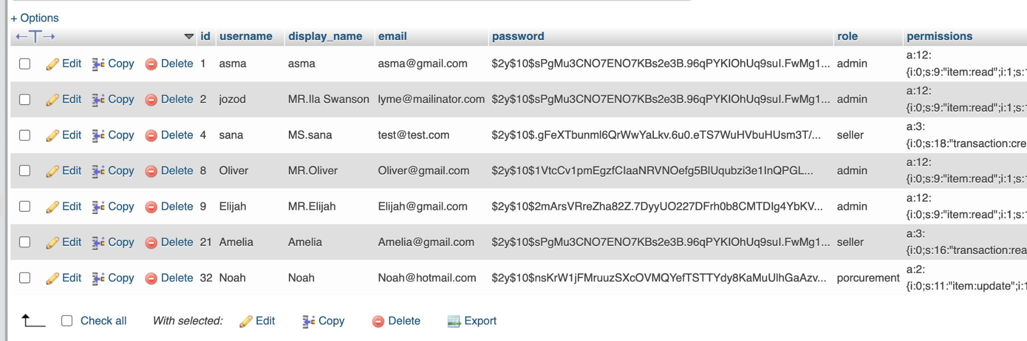

*Figure 8: users DB table*

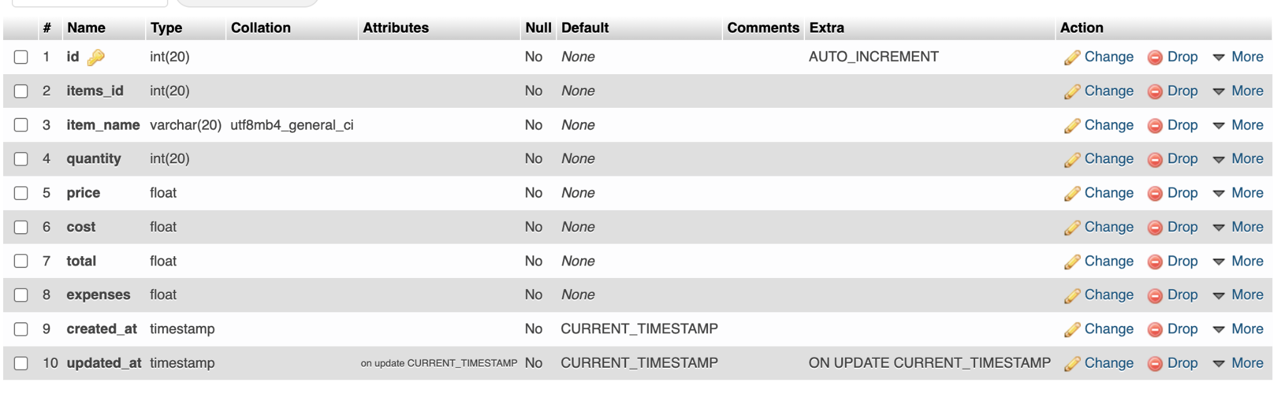

*Figure 9: transaction DB table*

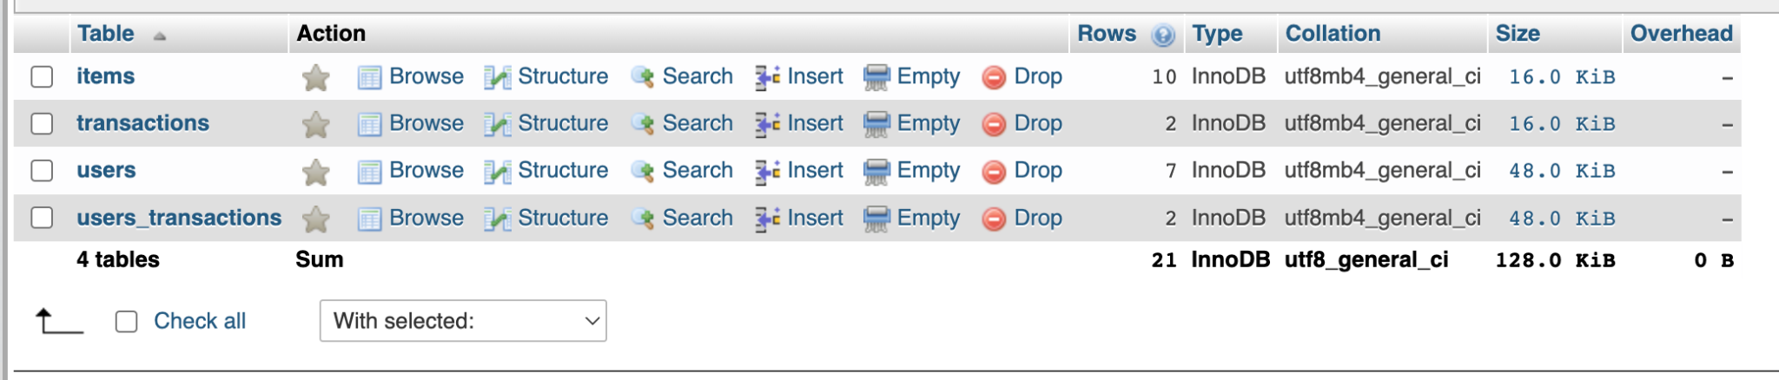

*Figure 10: usr-transaction DB table*

|  |
| --- |
|  |

**5.3 Graphical User Interface Implementation**

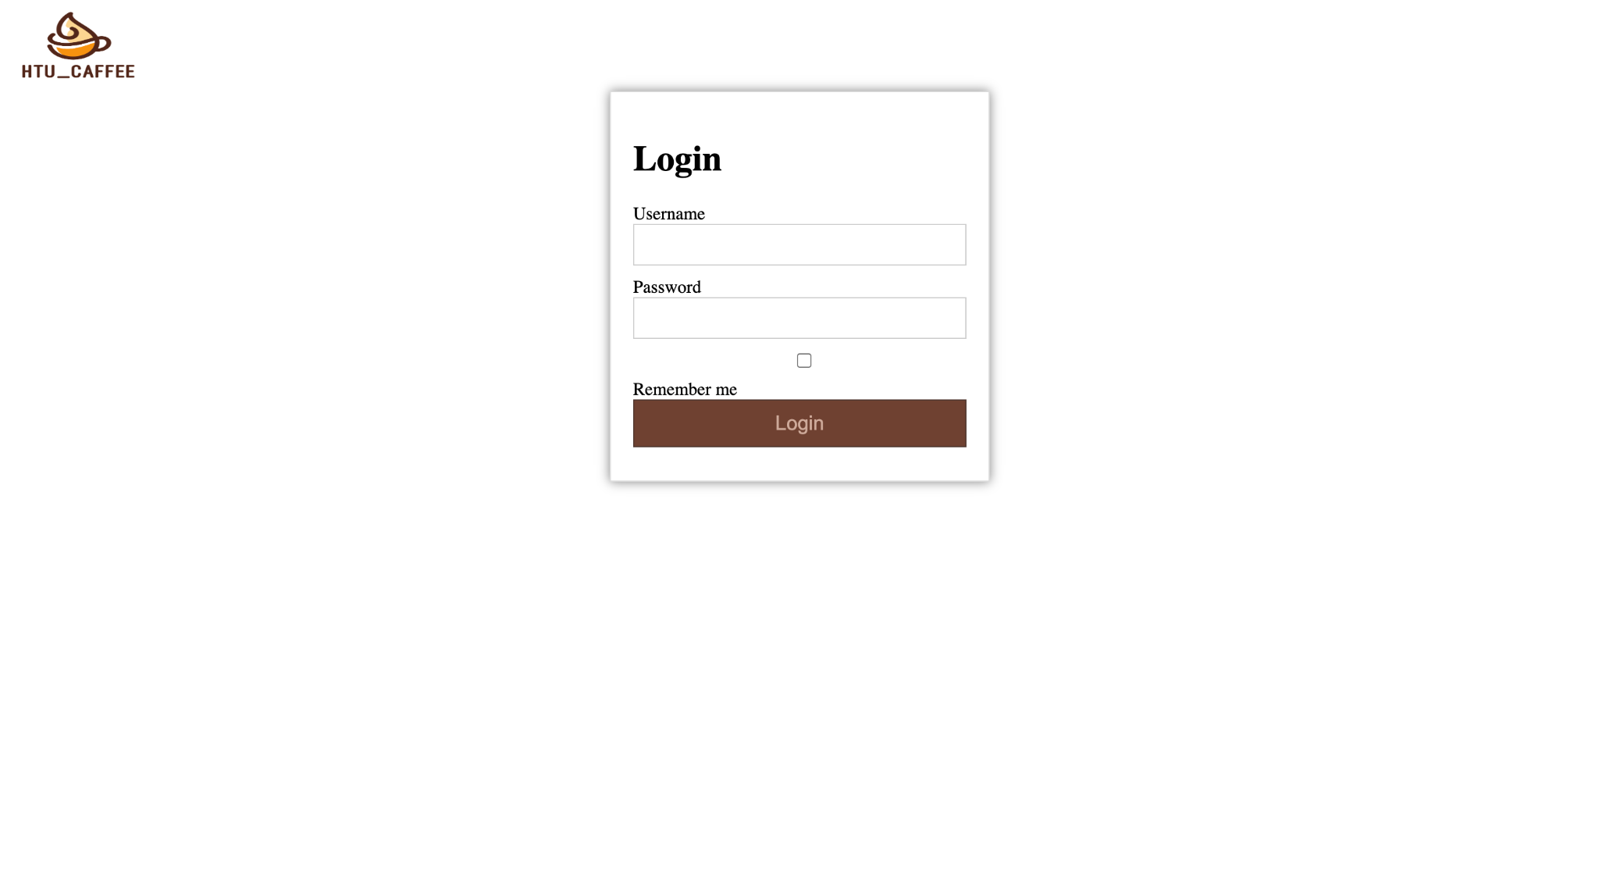

*Figure 11: login page*

by pressing the remember me checkbox it will save the user data for 30 dates and when press the login button it will take the user to his dashboard.

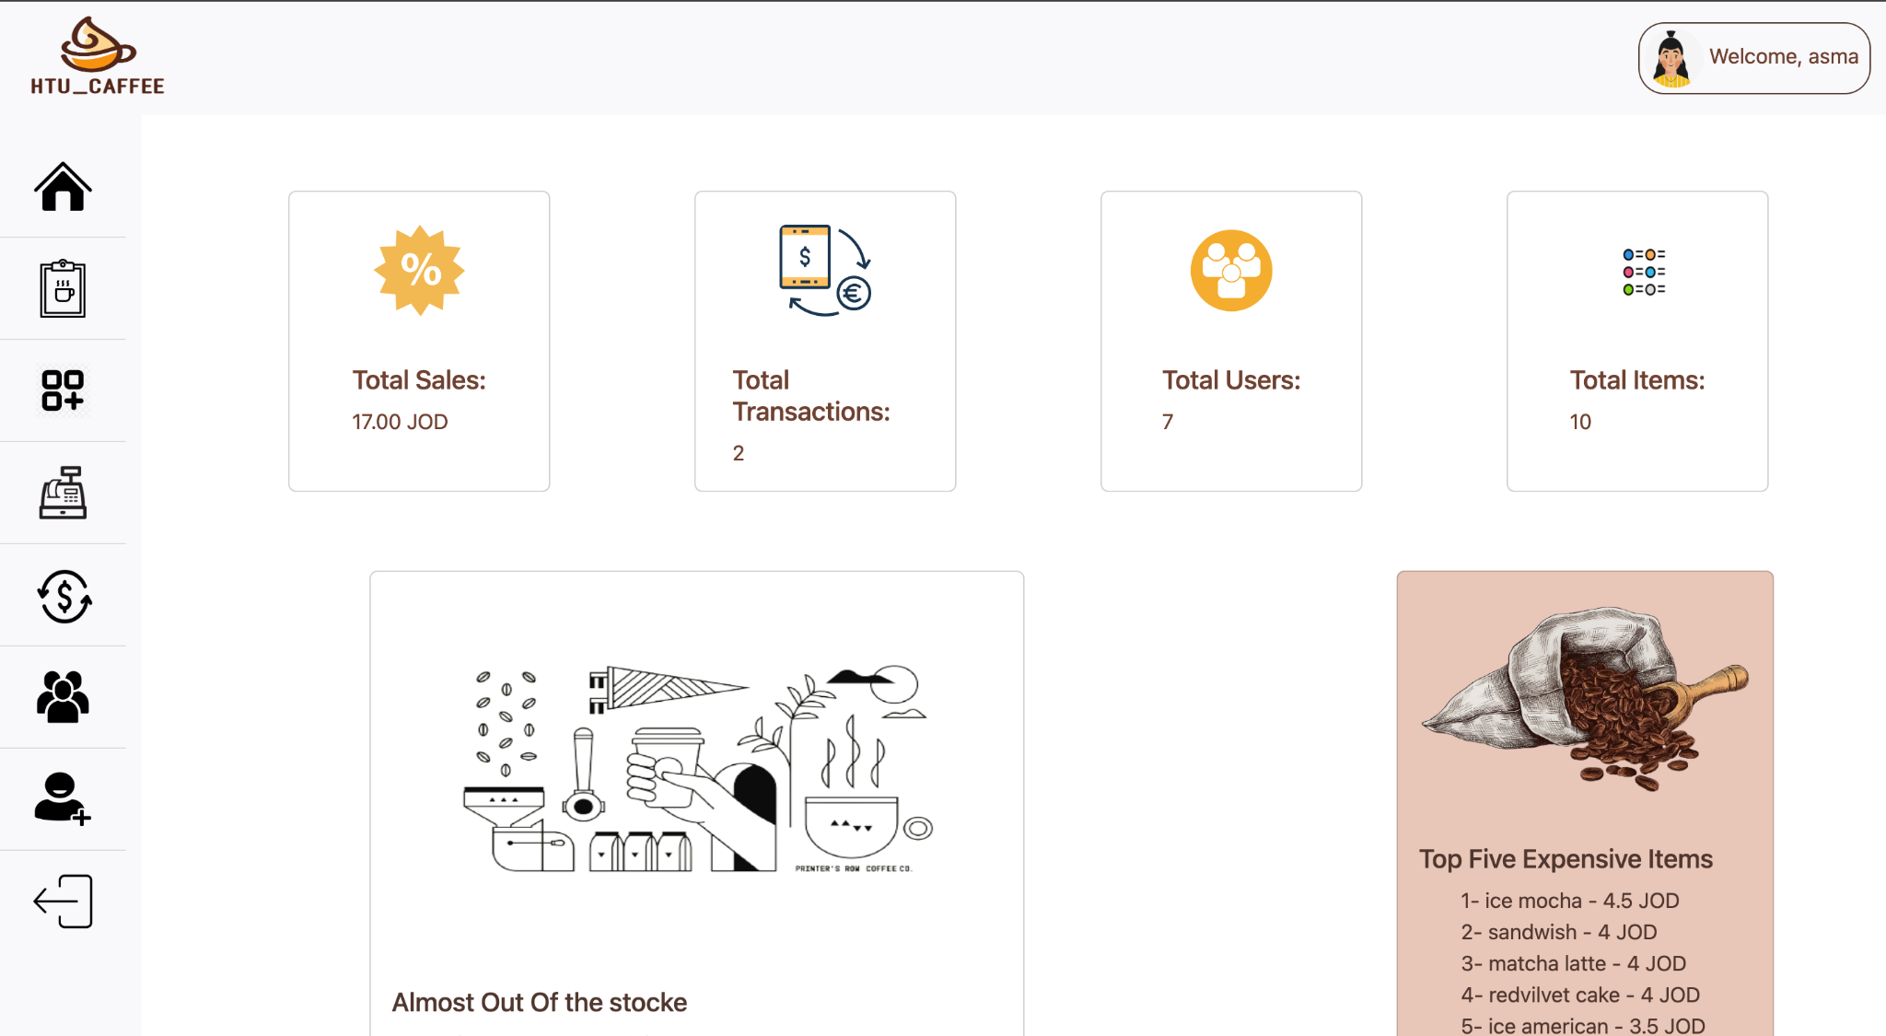

*Figure 12: admin dashboard page*

The admin dashboard is a page that is only accessible to users who have admin privileges. It displays important information such as total sales, total number of users, total number of items, and total number of transactions. The dashboard also displays the top five most expensive items and any items that are low in stock .The navbar contains a logo that takes the user back to their dashboard, as well as the name and photo of the user which takes the user to their profile. The side bar allows the user to navigate between pages, and is only visible to admins and users with the appropriate permissions. The logout icon allows the user to log out of the website.

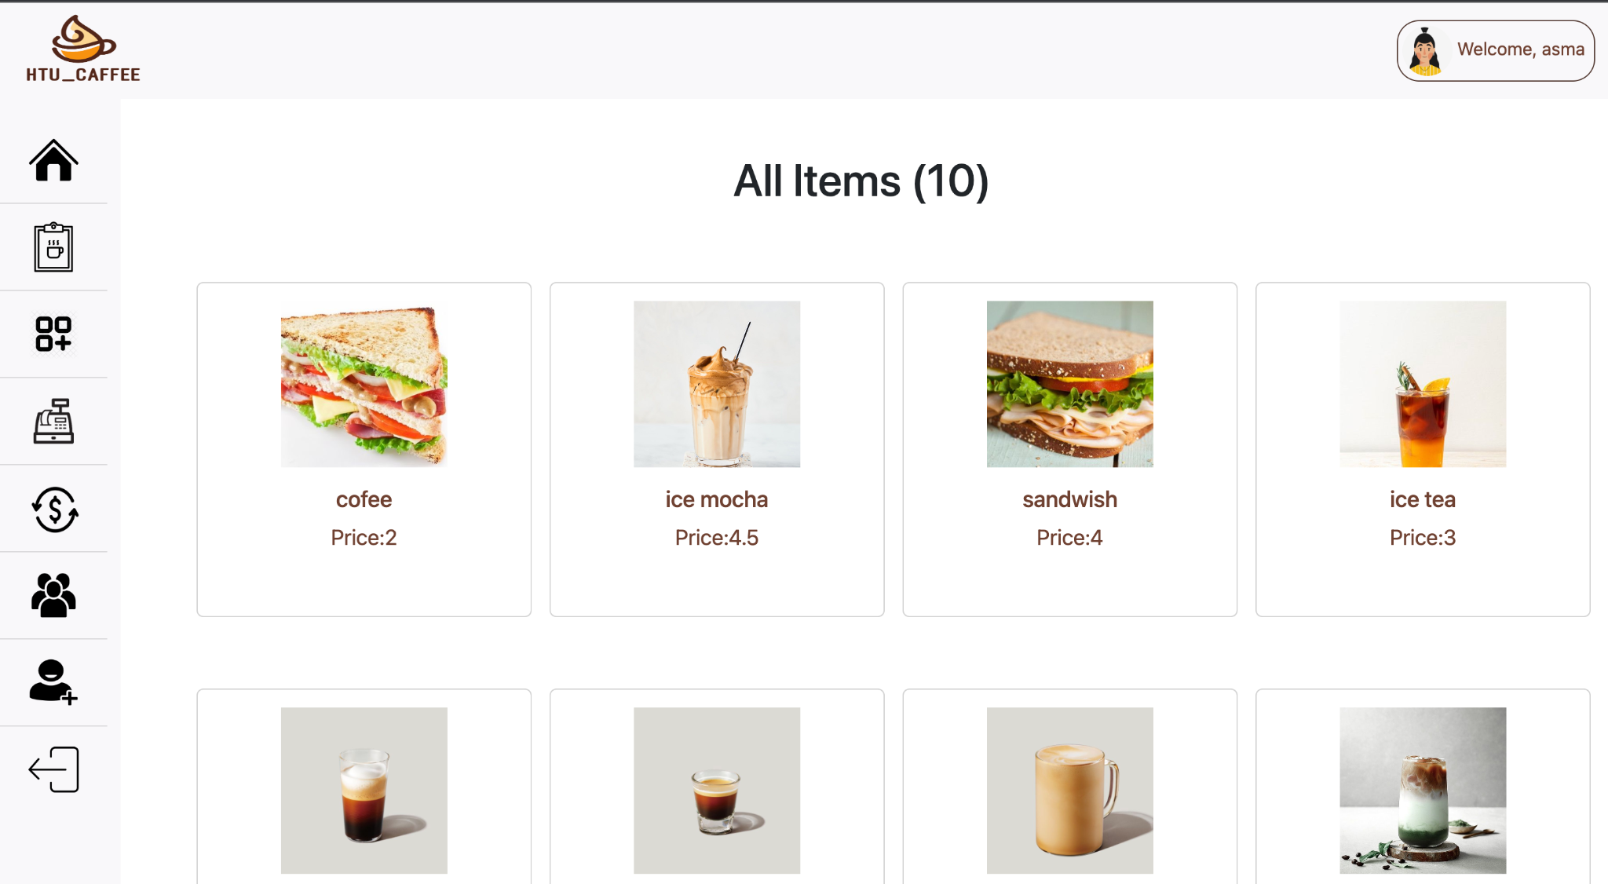

*Figure 13: all items page*

The all items page displays a list of item cards, each containing an image, name, and price for a specific item. The total number of items is also displayed on this page. By clicking on an item card, the user is taken to the single item page, which displays more detailed information about that specific item.

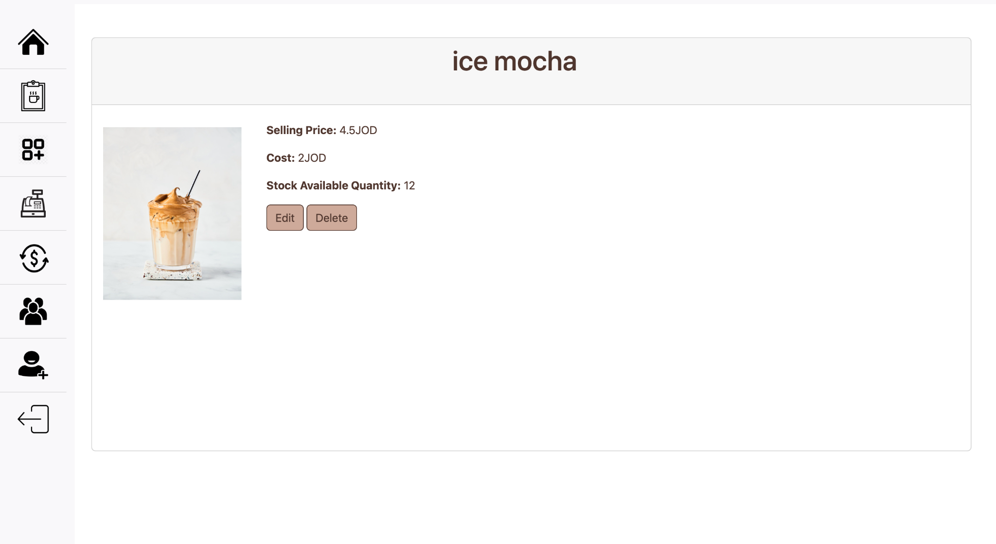

*Figure 14: single item page*

The single item page displays detailed information about a specific item, including its image, name, cost, stock availability, and price. It also includes edit and delete buttons which allow the user to either edit the item's information or delete the item entirely. The edit button takes the user to the edit item page, where they can make changes to the item's information. The delete button removes the item from the website.

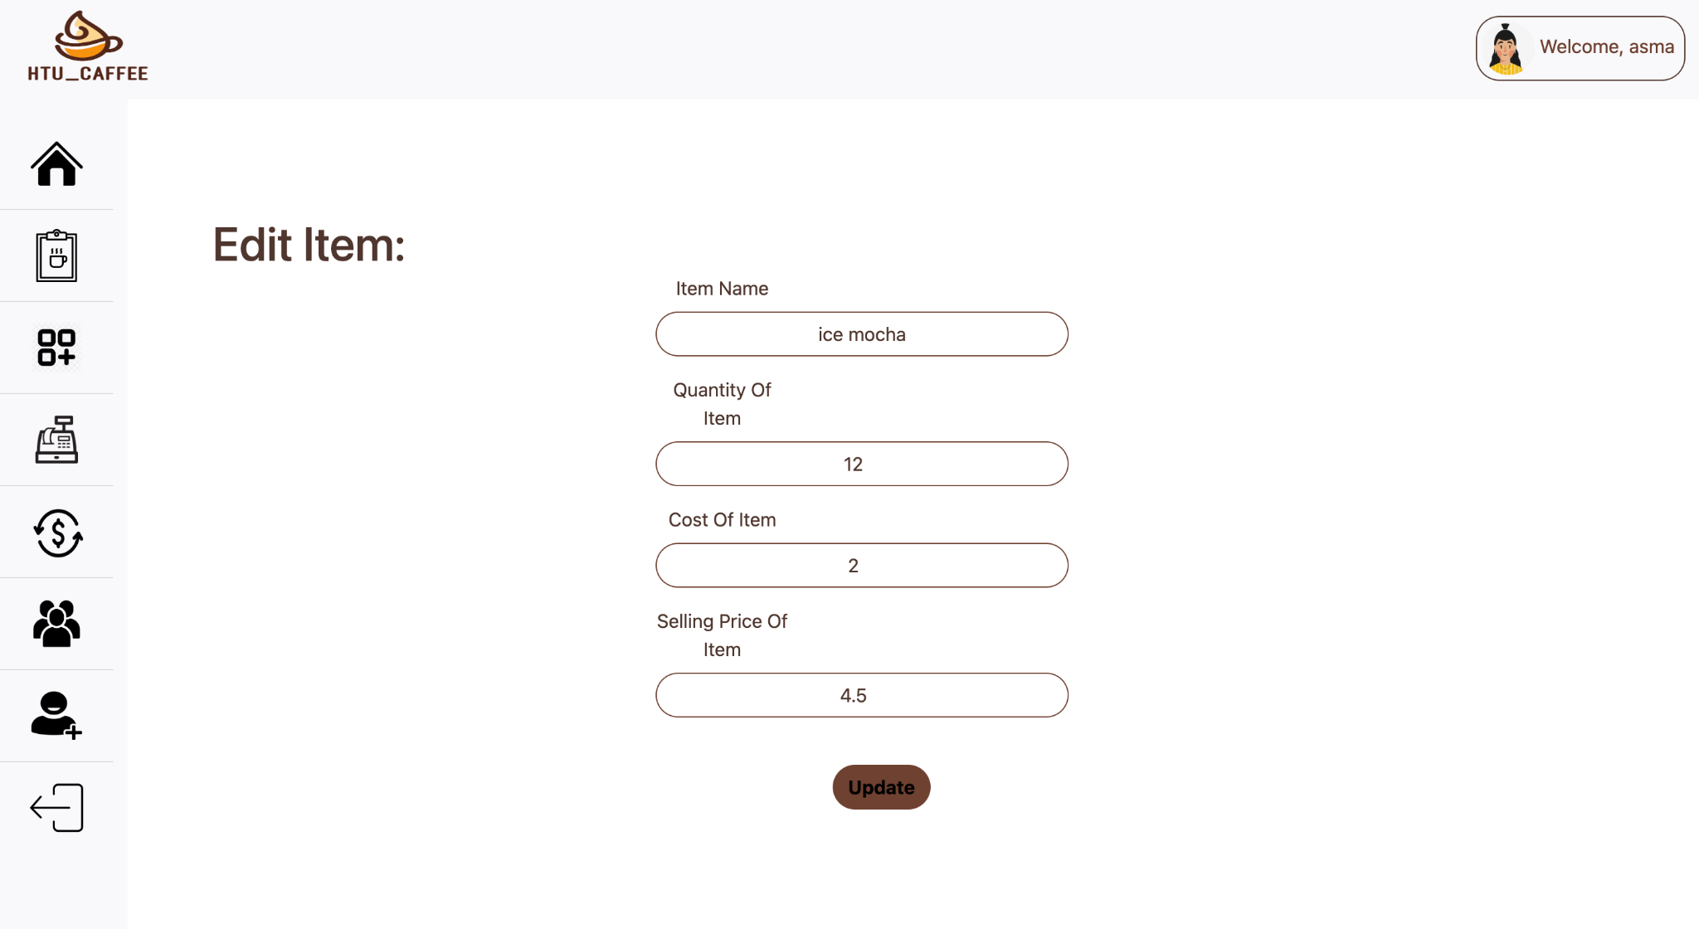*Figure 15: edit item page*

The edit item page displays a form with the current information for the item that the user wants to edit. When the user makes changes to the form and clicks the update button, the item's information is updated to reflect the changes that were made. This means that the item's information on the website will be changed to the new information that was entered into the form.

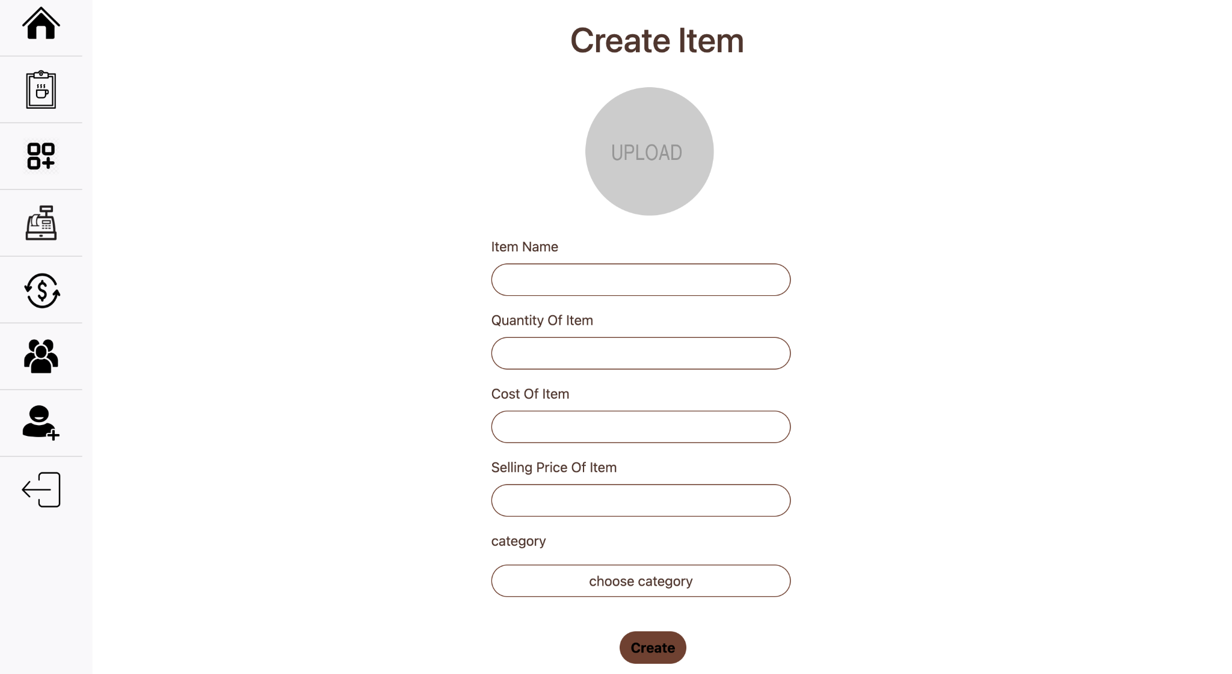*Figure 16: creat item page*

The create item page displays a form that allows the user to create a new item. When the user fills out the form and clicks the create button, a new item is created and added to the website. The form may ask for information such as the item's name, image, price, and any other relevant details. Once the create button is clicked, the new item is added to the website and can be accessed by users.

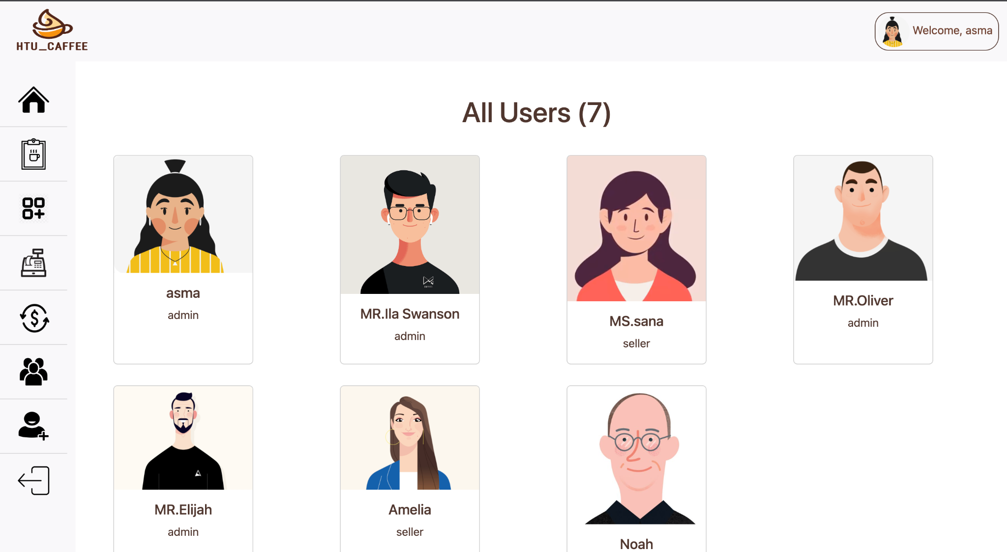

*Figure 17: all users page*

The all users page displays a list of user cards, each containing an image, name, and role for a specific user. The total number of users is also displayed on this page. By clicking on an user card, the user is taken to the single user page, which displays more detailed information about that specific user.

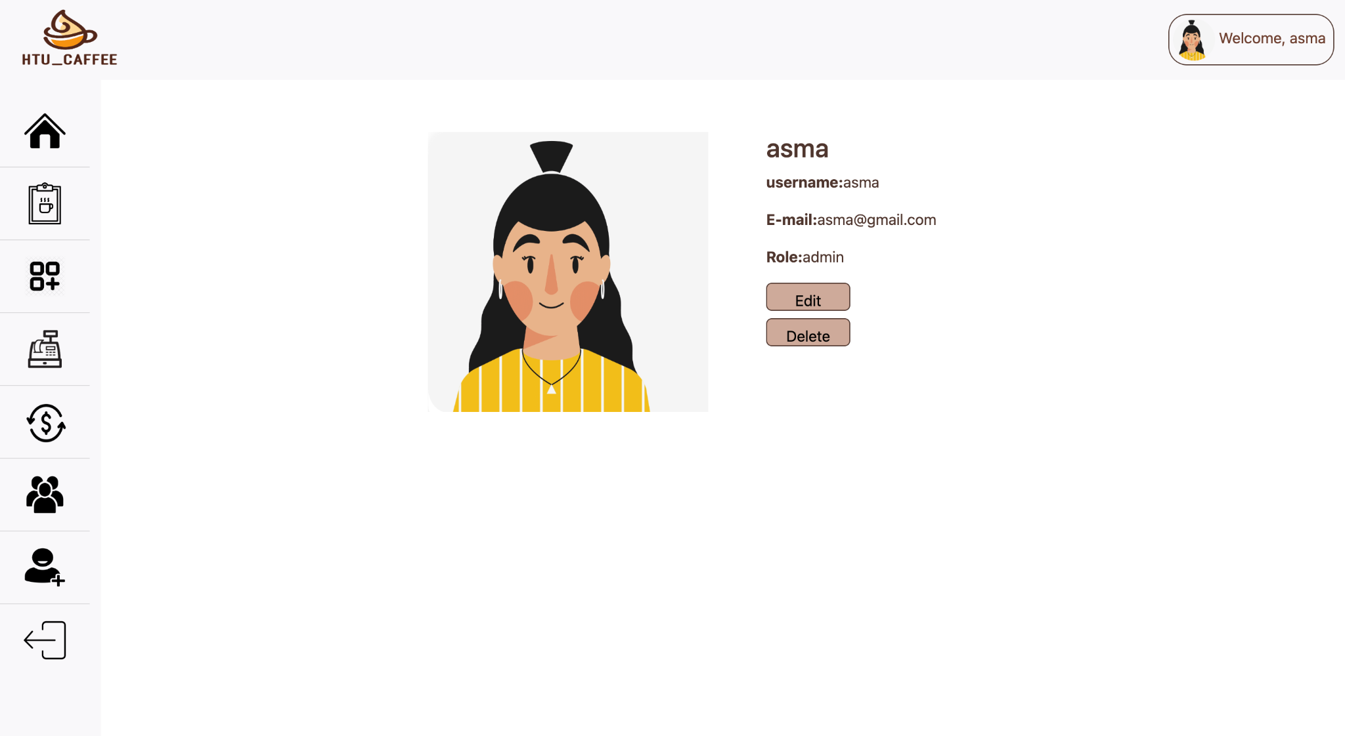*Figure 18: single users page*

The single user page displays detailed information about a specific user, such as their name, email address, role on the website. It may also include options to delete or edit the user's information. The delete button removes the user from the website, while the edit button takes the user to the edit user page.

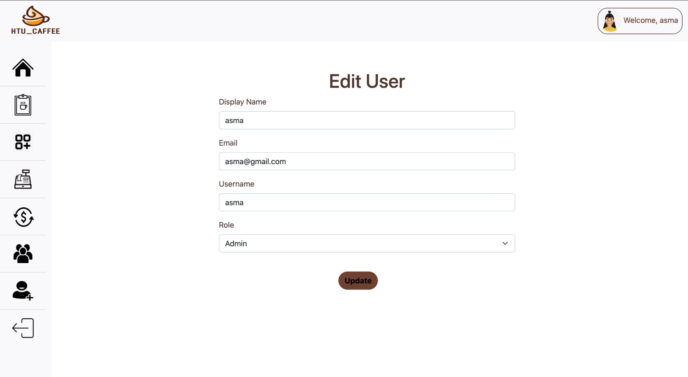

*Figure 19: edit users page*

The edit user page displays a form with the current information for the user that the user wants to edit. When the user makes changes to the form and clicks the update button, the user's information is updated to reflect the changes that were made. This means that the user's information on the website will be changed to the new information that was entered into the form.

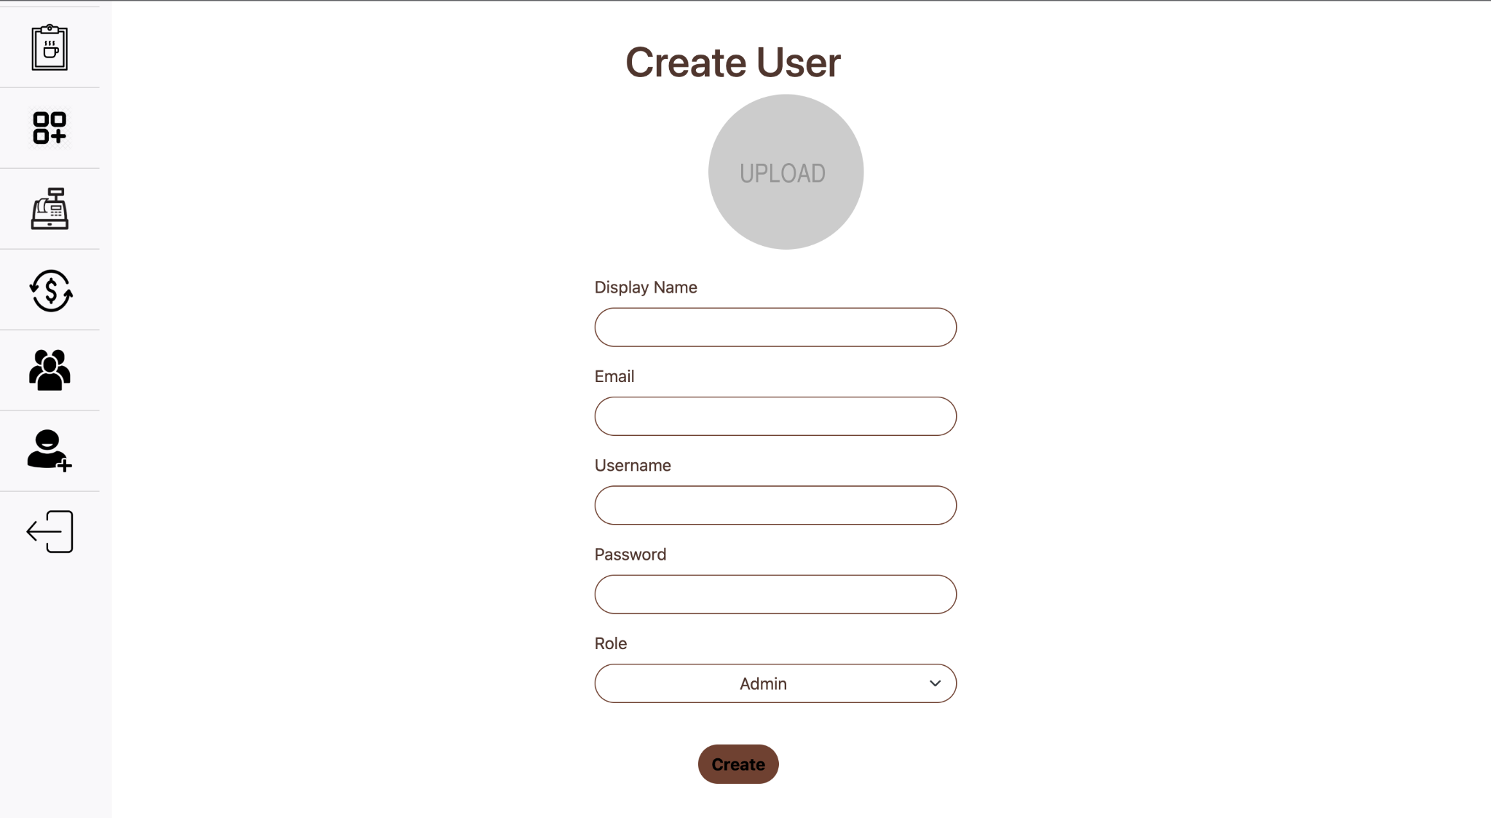

*Figure 20: create users page*

The create user page displays a form that allows the user to create a new user account. When the user fills out the form and clicks the create button, a new user is added to the website. The form may ask for information such as the user's name, email address, and any other relevant details. Once the create button is clicked, the new user is added to the website and can be accessed by other users.

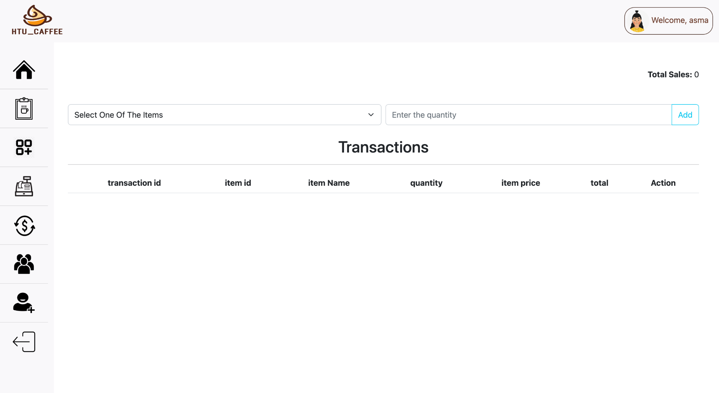

*Figure 21: sales page*

The sales page contains a form with a list of items that are available for purchase and a quantity field for each item. When the user selects an item and enters a quantity, a transaction is created and added to the transaction table. The transaction table displays the transaction ID, item ID, item name, quantity, item price, and total for each transaction. It may also include edit and delete buttons which allow the user to make changes to or delete a transaction. The sales page also displays the total sales for all transactions. The transaction table and total sales are updated in real-time as transactions are made.

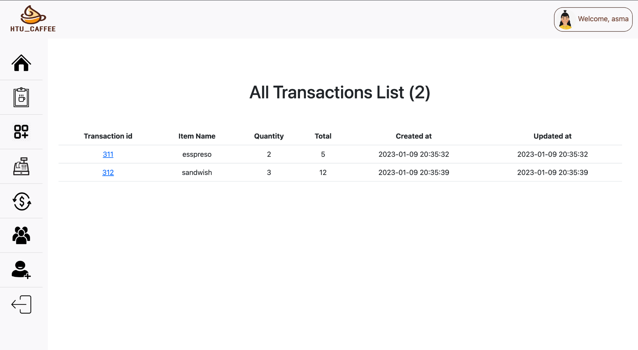

*Figure 22: all transaction page*

The all transactions page displays a table of all the transactions that have been made on the website. The table includes the transaction ID, item ID, item name, quantity, item price, and total for each transaction. It also displays the total number of transactions that have been made. By clicking on a transaction ID, the user is taken to the single transaction page, which displays more detailed information about that specific transaction. The all transactions page allows the user to view a complete record of all transactions that have been made on the website and access more detailed information about individual transactions.

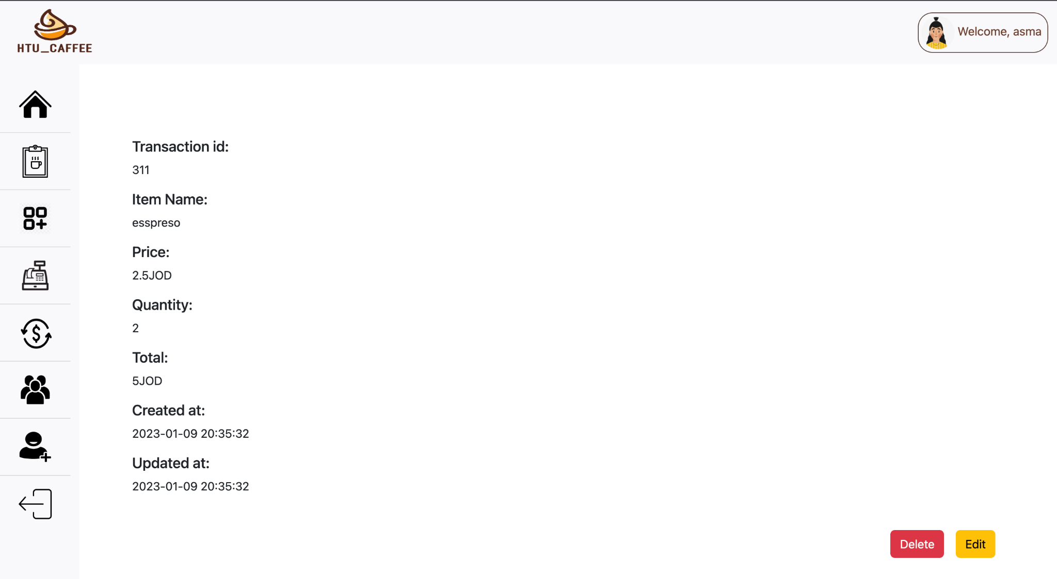

*Figure 23: single transaction page*

The single transaction page displays detailed information about a specific transaction, such as the transaction ID, item ID, item name, quantity, item price, and total. It may also include options to delete or edit the transaction. The delete button removes the transaction from the website, while the edit button takes the user to the edit transaction page.

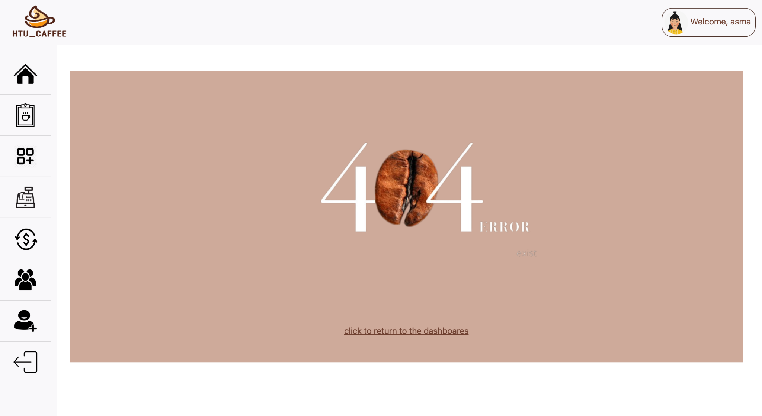

*Figure 24: 404 page*

404 page is an error page that is displayed when a user tries to access a webpage that does not exist or is not available. The 404 page typically includes a message indicating that the requested page could not be found and may include suggestions for what the user can do next, such as returning to the homepage or searching for a different page. The 404 page is an important part of a website because it helps to inform the user when they have reached a page that is not available and guides them towards other options.

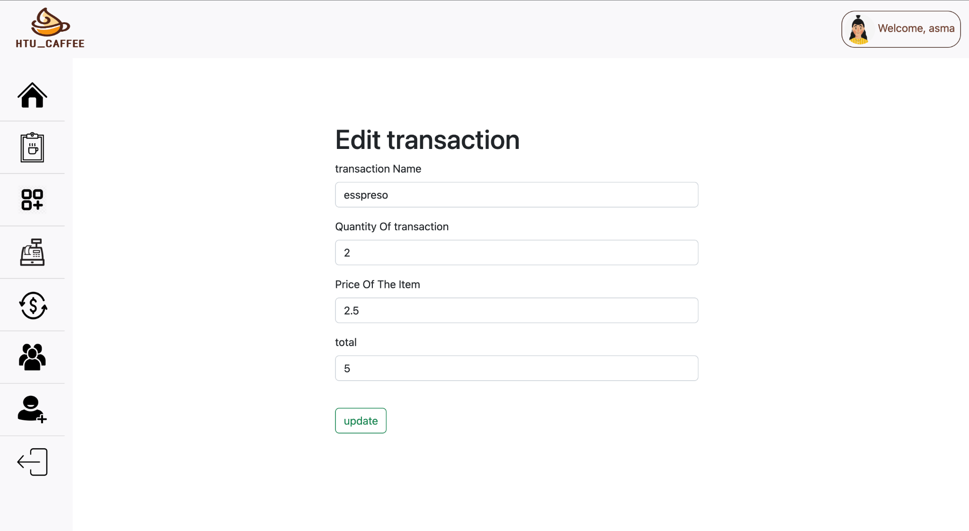

*Figure 24: edit transaction page*

The edit transaction page displays a form with the current information for the transaction that the user wants to edit. When the user makes changes to the form and clicks the update button, the transaction is updated to reflect the changes that were made. This means that the transaction's information on the website will be changed to the new information that was entered into the form. The edit transaction page allows the user to make changes to the details of a specific transaction.

6. **Conclusion and future work**

**6.1** Introduction

The website will help HTU handle the store sales transactions and stock in an easy to use and clear way.

**6.2 Overall Weakness**

**One weakness of our project is that we need constant internet connection to access the website and benefit from its features . ​​ Plus our website is in English, we haven't worked on an Arabic version yet.**

**6.3 Overall strengths**

**The website is easy and clear so it's marked to be easy to use, making it usable by all segments of society. also, the website gives low-stock items which reminds the user to restock and if the item was out of stock the user can't sell the item so there will be no unwantable mistakes.**

**6.4 Future work**

**Our future scope for the project is to build different versions of the website in different languages, and I will put a search bar so the user can easily search for an item or another user.**

7. **References**

References:

1)<https://www.foodics.com/rms-pos/?utm_medium=g&utm_source=google_paid&utm_term=square&utm_campaign=Search_Jordan_EN_Competitor&hsa_acc=8120928309&hsa_cam=16509353202&hsa_grp=135459027818&hsa_ad=586626966871&hsa_src=g&hsa_tgt=kwd-102671558&hsa_kw=square&hsa_mt=p&hsa_net=adwords&hsa_ver=3&gclid=CjwKCAiAk--dBhABEiwAchIwkRJdCQwRWjjCnBLAKL1kkj6KlfPJpu0NHp5Y_NPvhGrNYyUNELKj1RoCF9MQAvD_BwE>.

2)<https://www.lightspeedhq.com/shopkeep/>.

3)<https://www.lightspeedhq.com/>.

4)<https://app.diagrams.net/?src=about#G1d6T7A6C2mTTAJvejA5s5PhpvfQPQN4WU>.

5)<http://localhost/phpMyAdmin5/index.php?route=/sql&server=1&db=pos&table=users&pos=0>.

6)<https://www.mamp.info/en/downloads/>.

7)<https://code.visualstudio.com/download>.

8)<https://www.google.com/>.

9)<https://www.freepik.com/>.

10)<https://stackoverflow.com/>.

11)https://getbootstrap.com/.